I want to make a Mobile driving game where you have to dodge obstacles and complete levels, you will be able to buy and pickup power-ups, you will also be able to choose different vehicles, I would also like to have a option where you can chose the color of your vehicle, I want the game to have a slight 2d style but it will be 3d.

The UI will consist of music controls where you can adjust the volume of the music and sfx, or you can mute them with a button. The UI will also have screens to customize your vehicle and buy power ups, and there will also be a pause menu and a start screen, there will also be a help screen where you can view / customise the controls.

To handle the vehicle you will have to slide your finger or mouse to engage a drift to turn

This is the wireframe for the start screen:

The start screen will have a animated flashing title and a background of the game (possibly a live background) it will have a store option which will take you to the place to buy power ups with your coins, there is also the start button which will load the game, and there is a settings button which will take you to a screen where you can adjust the audio and where you can access the game controls and help screen.

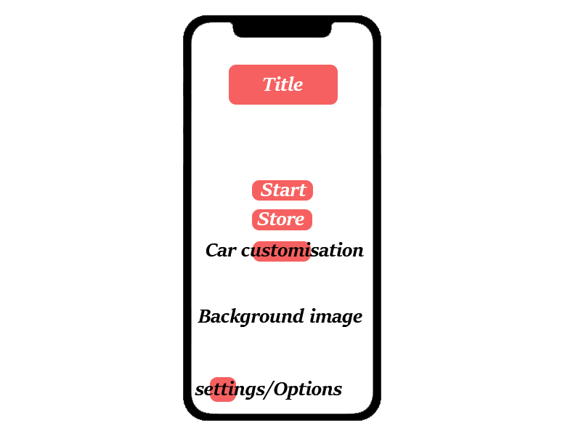

The next screen is the start screen:

On this screen there will be a bar at the top that shows you your progress through the level, there will also be a coin counter, a pause button, and a powerups button to use your power ups.there will also be a quick animation that plays to show you where to swipe to control the vehicle

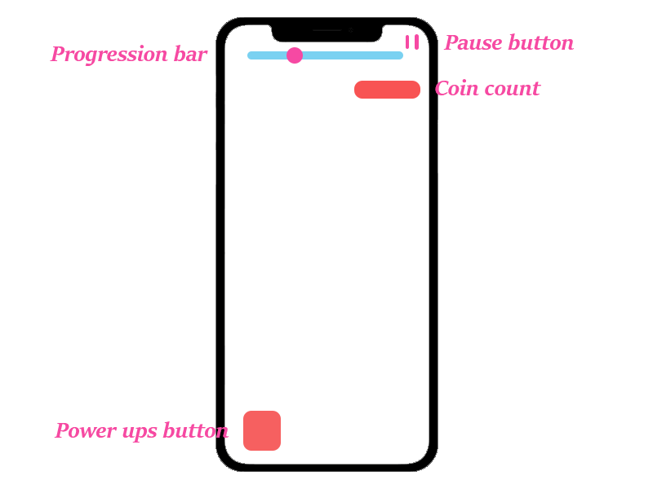

The next screen is the store screen:

On this screen there will be multiple options for example there will be a button to upgrade NOS which is a speed boost, you will find these powerups dotted around the map, there will also be other power ups such as a god mode one. There will also be information telling you what happens when you purchase a powerup upgrade.

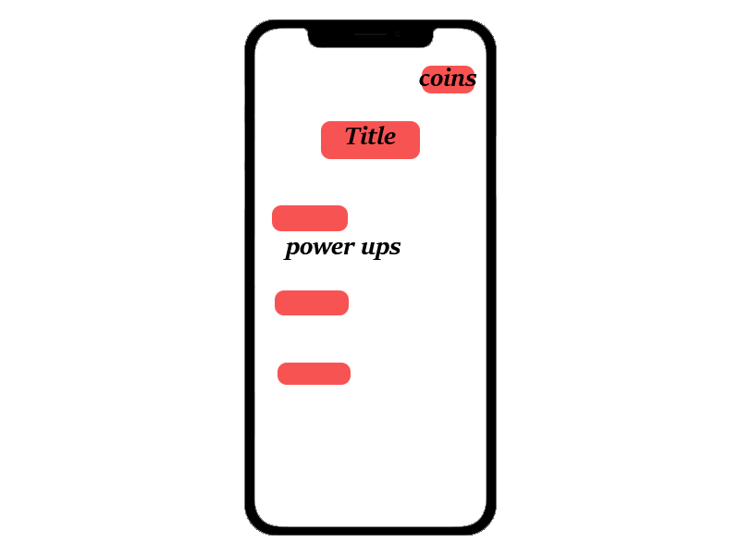

The next Wireframe is the Car customisation screen.

On this screen you will be able to choose from a different set of cars, and you will be able to choose the colour from a preset amount of colours.

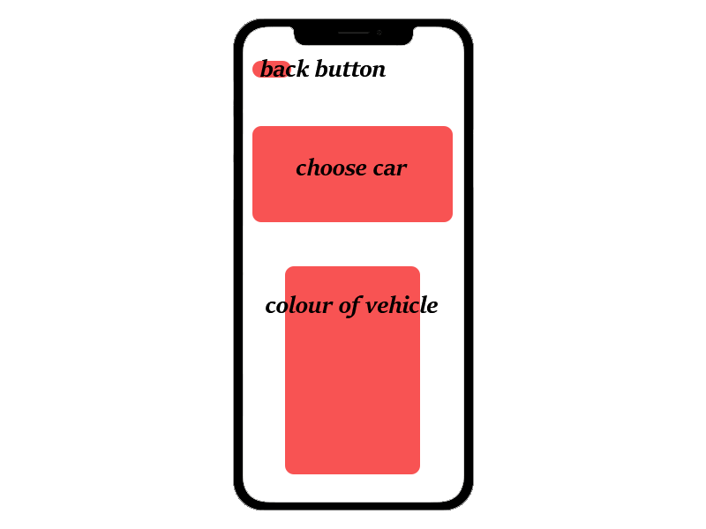

The next wireframe is the settings screen.

On this screen you will be able to choose whether you want to look at the controls or adjust the game sounds.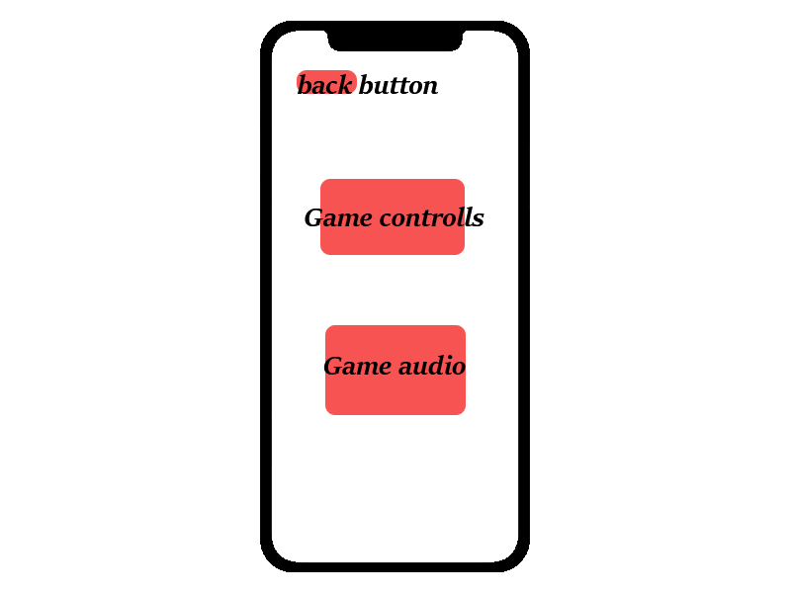

The next wireframe is the level selection screen.

On this screen you will be able to select different levels that are available to play.

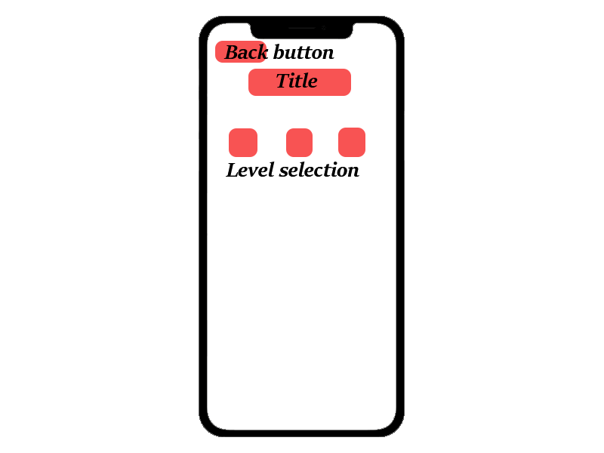

The next screen is the controls screen.

On this screen a small animation will repeat to show you how you can play.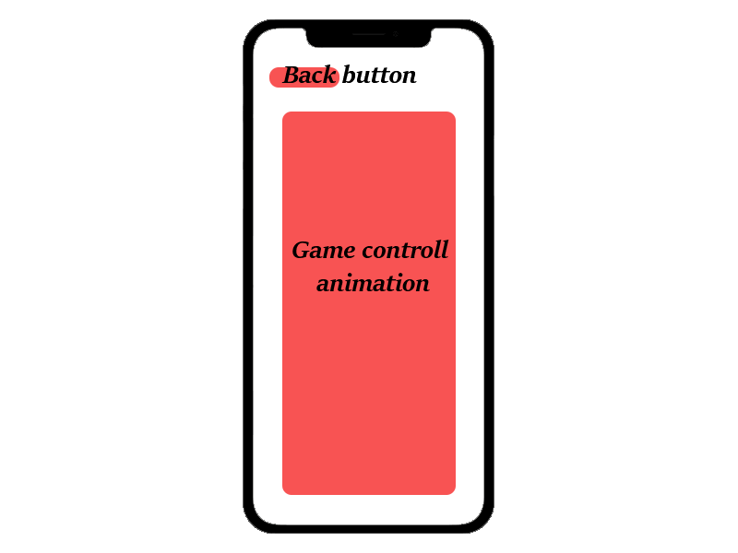

The next screen is the audio and sfx control screen.

On this screen you will be able to customise the audio for everything, there will be a master volume slider and mute button which will control all the audio, and there will be individual ones

.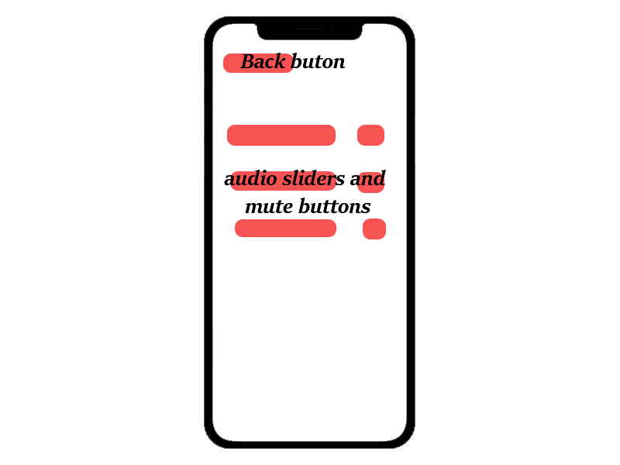

Here are the 3 level designs:

These levels will consist of obstacles to avoid and they will have buildings off to the side for aesthetic purposes.



This is the style I am going for, It is a 8bit style game.